COMP 353 CC

Main Project

Group Account: tyc353_1



|  |  |
| --- | --- |
| **Member** | **ID** |
| Mei Liu | 40060940 |



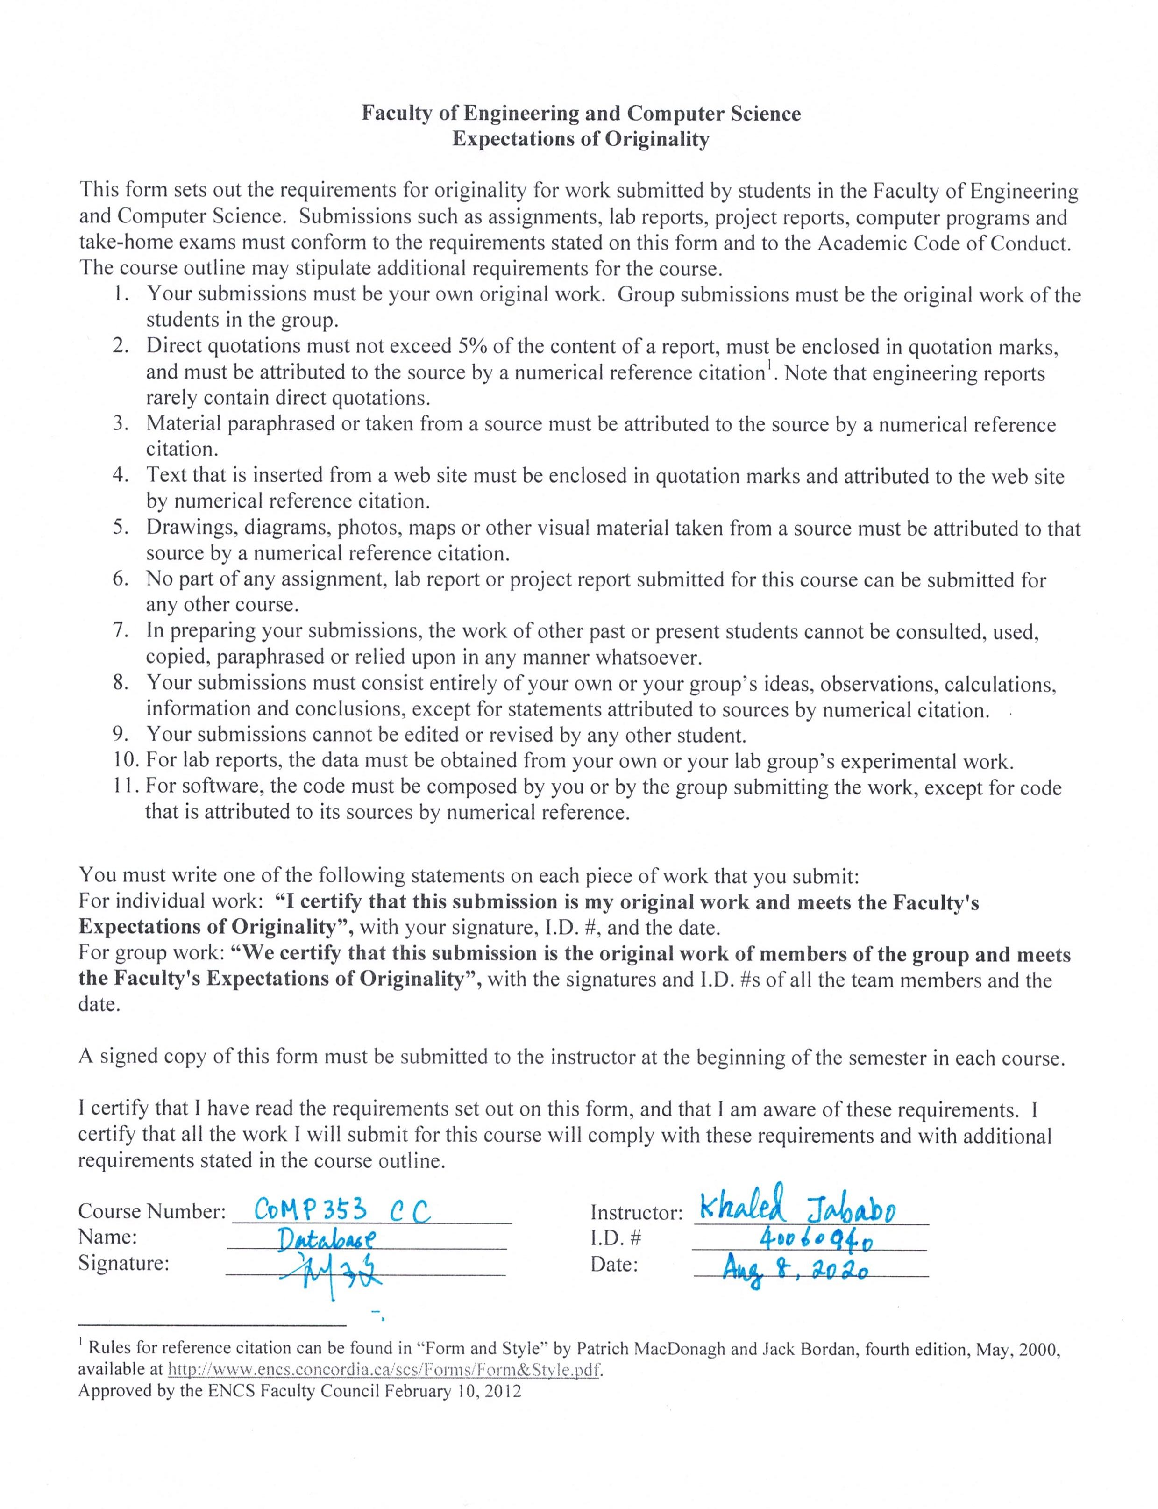

**TABLE OF CONTENTS**

1. Overview 5

2. ER Design 5

3. Relational database scheme and Normalization 6

4. Functionalities. 10

5. All Relations Declaration 26

**LIST OF FIGURES**

Figure 1 : ER Diagram 5

Figure 2: Output of query i of Create 11

Figure 3: Output of query i of Delete 11

Figure 4: Output of query i of Edit 12

Figure 5: Output of query i of Display 12

Figure 6: Output of query ii of Create 13

Figure 7: Output of query ii of Delete 14

Figure 8: Output of query ii of Edit 15

Figure 9: Output of query ii of Display 15

Figure 10: Output of query iii 16

Figure 11: Output of query iv 17

Figure 12: Output of query v 18

Figure 13: Output of query vi 18

Figure 14: Output of query vii of Create 19

Figure 15: Output of query vii of Delete 19

Figure 16: Output of query vii of Edit 20

Figure 17: Output of query vii of Display 20

Figure 18: Output of query viii 20

Figure 19: Output of query ix 21

Figure 20: Output of query x of Accept 22

Figure 21: Output of query x of Deny 22

Figure 22: Output of query xi 23

Figure 23: Output of query xii 24

Figure 24: Output of query xiii 24

Figure 25: Output of query xiv of Add 25

Figure 26: Output of query xiv of Delete 25

Figure 27: Output of query xiv of Edit 26

Figure 28: Output of query xv of Create 26

Figure 29: Output of query xv of Delete 27

Figure 30: Output of query xv of Edit 27

Figure 31: Output of query xvi 28

# Overview

This project is aimed to build up a Web Career Portal for employers and employees to facilitate their day to day tasks and provide a better service for their clients.

Based upon requirements for two major entities in this project: Employers and Employees, the reasonable assumptions we have made is that several relations among Employers, Employees and Website Administrator should be created, and accosicated with payment information and job information, such that an effective database could be built up to support all those basic requirements. Meanwhile, we should normalize all relations in 3NF so as to avoid redundant data as much as possible.

# ER Design

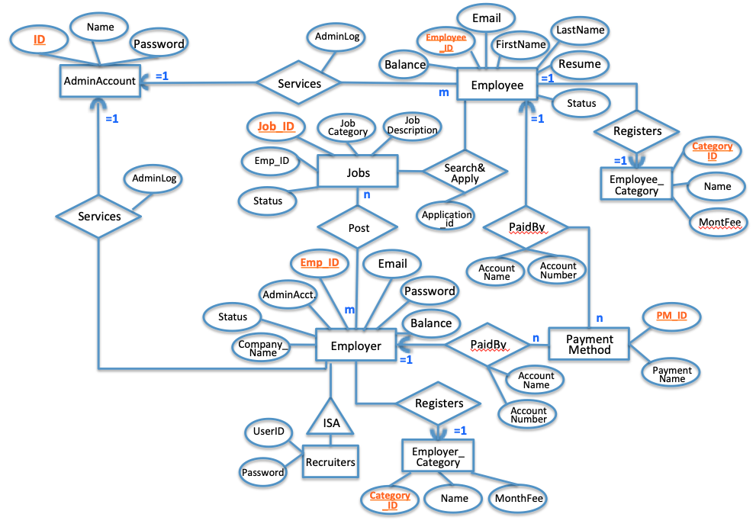According to the requirement, the figure 1 is the the designed ER diagram, which illustrates the conceptual database scheme.

Figure 1 : ER Diagram

# Relational database scheme and Normalization

Based the ER design, the relational database scheme Identify the primary keys and the foreign keys; and the referential integrity constraints is also noted.

Normalization of 3NF is also indicated by showing FD sets and candidate key identification.

**ADMIN_ACCOUNT** (**nam**e, password, email)

Primary key: name

Foreign key: nil

NORMALIZATION:

F = {name 🡪 password, name🡪email}

Candidate key = name

**All LHS of FDs are candidate key, therefore R is in 3NF.**

**ADMIN_LOG** (**log_id**, log_time, activity)

Primary key: log_id

Foreign key: nil

NORMALIZATION:

F = {log_id 🡪 log_time, log_id 🡪 activity }

Candidate key = log_id

**All LHS of FDs are candidate key, therefore R is in 3NF.**

**EMPLOYER** (**employer_id,** name, password, company, email, category, status, balance, last_pay_time, auto_pay, default_pm_id)

Primary Key: employer_id

Foreign Key:category, pm_id

Notes for Referential Integrity:

* The category must match a valid category_id in the relation EMPLOYER_CATEGORY
* The default_pm_id must match a valid pm_id in the PAYMENT_EMPLOYER

Normalization:

F = { employer_id 🡪 name, employer_id 🡪 password, employer_id 🡪 company, employer_id 🡪 email, employer_id 🡪 category, employer_id 🡪 status, employer_id 🡪 balance, employer_id 🡪 last_pay_time, employer_id 🡪 auto_pay, employer_id 🡪 pm_id}

Candidate key = employer_id

**All LHS of FDs are candidate key, therefore R is in 3NF.**

**EMPLOYER_CATEGORY (category_id**, category, month_fee)

Primary Key: category_id

Foreign Key:nil

Normalization:

F = { category_id 🡪 category, category_id 🡪 month_fee}

Candidate key = category_id

**All LHS of FDs are candidate key, therefore R is in 3NF.**

**PAYMENT_EMPLOYER** (**pm_id**, employer_id, pay_method, account_name, account_number)

Primary Key: pm_id

Foreign Key:employer_id

Notes for Referential Integrity:

* The employer_id must match a valid employer_id in the relation EMPLOYER.

Normalization:

F = { pm_id 🡪 employer_id, pm_id 🡪 pay_method, pm_id 🡪 account_name, pm_id 🡪 account_number }

Candidate key = employer_id

**All LHS of FDs are candidate key, therefore R is in 3NF.**

**RECRUITER** (**recruiter_id**, employer_id, name, password, first_name, last_name, email)

Primary Key: recruiter_id

Foreign Key:employer_id

Notes for Referential Integrity:

* The employer_id must match a valid employer_id in the relation EMPLOYER.

Normalization:

F = { recruiter_id 🡪 employer_id, recruiter_id 🡪 name, recruiter_id 🡪 first_name, recruiter_id 🡪 last_name, recruiter_id 🡪 email }

Candidate key = recruiter_id

**All LHS of FDs are candidate key, therefore R is in 3NF.**

**EMPLOYEE** (**employee_id**, name, first_name, last_name, email, category, status, balance, resume, last_pay_time, auto_pay, default_pm_id)

Primary Key: employee_id

Foreign Key:default_pm_id, category

Notes for Referential Integrity:

* The default_pm_id must match a valid pm_id in the relation PAYMENT_EMPLOYEE.
* The category must match a valid category id in the relation EMPLOYEECATEGORY.

Normalization:

F = { employee_id 🡪 name, employee_id 🡪 first_name, employee_id 🡪 last_name, employee_id 🡪 email , employee_id 🡪 category , employee_id 🡪 status , employee_id 🡪 balance , employee_id 🡪 resume , employee_id 🡪 last_pay_time , employee_id 🡪 auto_pay, employee_id 🡪 default_pm_id}

Candidate key = employee_id

**All LHS of FDs are candidate key, therefore R is in 3NF.**

**EMPLOYEE_CATEGORY (category_id**, category, month_fee)

Primary Key: category_id

Foreign Key:nil

Normalization:

F = { category_id 🡪 category, category_id 🡪 month_fee}

Candidate key = category_id

**All LHS of FDs are candidate key, therefore R is in 3NF.**

**PAYMENT_EMPLOYEE** (**pm_id**, employer_id, pay_method, account_name, account_number)

Primary Key: pm_id

Foreign Key:employee_id

Notes for Referential Integrity:

* The employer_id must match a valid employer_id in the relation EMPLOYEE.

Normalization:

F = { pm_id 🡪 employee_id, pm_id 🡪 pay_method, pm_id 🡪 account_name, pm_id 🡪 account_number }

Candidate key = employer_id

**All LHS of FDs are candidate key, therefore R is in 3NF.**

**AUTO_PAY** (**auto_pay**, value)

Primary Key: auto_pay

Foreign Key:nil

Normalization:

F = { auto_pay 🡪 value}

Candidate key = auto_pay

**All LHS of FDs are candidate key, therefore R is in 3NF.**

**PAYMENT_METHOD** (**method_id**, method_name)

Primary Key: method_id

Foreign Key:nil

Normalization:

F = { method_id 🡪 method_name}

Candidate key = method_id

**All LHS of FDs are candidate key, therefore R is in 3NF.**

**JOB** (**job_id**, employer_id, title, needed, job_cid, description, status, post_time)

Primary Key: job_id

Foreign Key:employee_id, job_cid

Notes for Referential Integrity:

* The employer_id must match a valid employer_id in the relation EMPLOYEE.
* The job_cid must match a valid job_cid in the relation JOB_CATEGORY

Normalization:

F = { job_id 🡪 employee_id, job_id 🡪 title, job_id 🡪 needed, job_id 🡪 job_cid, job_id 🡪 description, job_id 🡪 status, job_id 🡪 post_time}

Candidate key = job_id

**All LHS of FDs are candidate key, therefore R is in 3NF.**

**JOB_CATEGORY** (**job_cid**, employer_id, category)

Primary Key: job_cid

Foreign Key:employee_id

Notes for Referential Integrity:

* The employer_id must match a valid employer_id in the relation EMPLOYEE.

Normalization:

F = { job_cid 🡪 employee_id, job_cid 🡪 category}

Candidate key = job_cid

**All LHS of FDs are candidate key, therefore R is in 3NF.**

**APPLICATION** (**app_id**, job_id, employee_id, status_id, apply_time, )

Primary Key: app_id

Foreign Key:employee_id

Notes for Referential Integrity:

* The employer_id must match a valid employer_id in the relation EMPLOYEE.

Normalization:

F = { app_id 🡪 employee_id, app_id 🡪 job_id, app_id 🡪 status_id, app_id 🡪 apploy_time}

Candidate key = app_id

**All LHS of FDs are candidate key, therefore R is in 3NF.**

**APPLICATION_STATUS** (**status_id**, status )

Primary Key: status_id

Foreign Key:nil

Normalization:

F = { status_id 🡪status}

Candidate key = status

**All LHS of FDs are candidate key, therefore R is in 3NF.**

# Functionalities.

i.Create/Delete/Edit/Display an Employer.

Create:

INSERT INTO TB_EMPLOYER VALUES (108,'admin',1,'Infinity Tech', 'hiring@ift.ca',2,0,0,NULL,1,NULL);

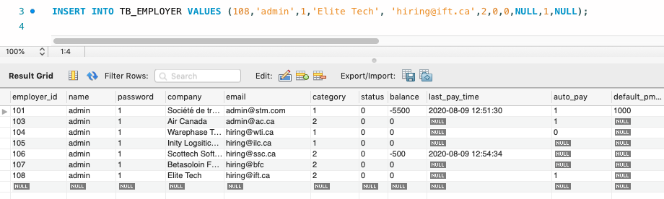

Figure 2: Output of query i of Create

Delete:

DELETE FROM TB_EMPLOYER WHERE employer_id=108;

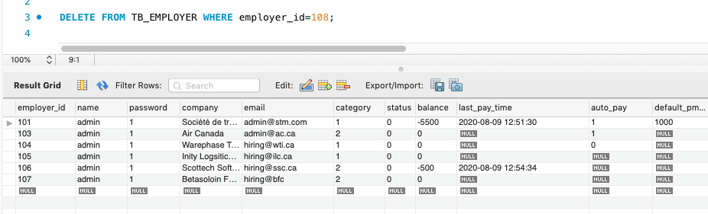

Figure 3: Output of query i of Delete

Edit:

UPDATE TB_EMPLOYER

SET auto_pay = 1, category =2

WHERE employer_id = 103;

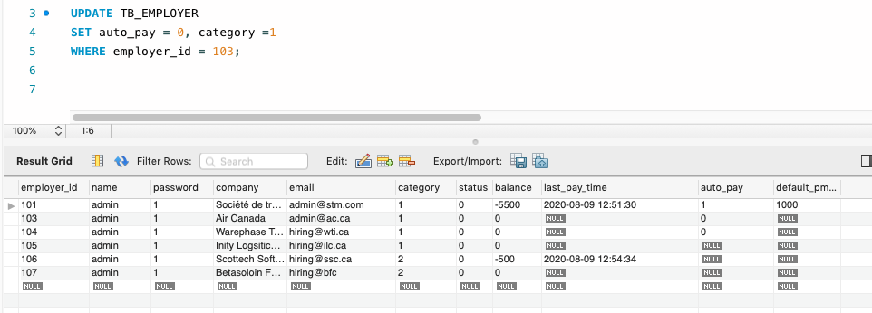

Figure 4: Output of query i of Edit

Display

select * FROM TB_EMPLOYER

WHERE employer_id = 103;

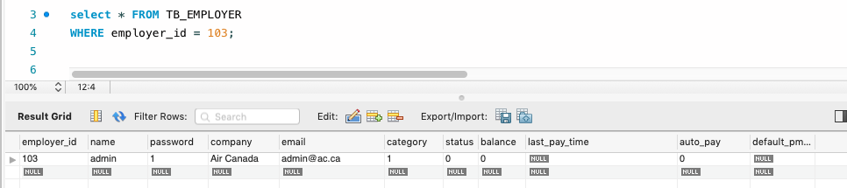

Figure 5: Output of query i of Display

ii Create/Delete/Edit/Display a category by an Employer.

Create:

INSERT INTO TB_JOB_CATEGORY (employer_id,category) VALUES (105,'Engineering');

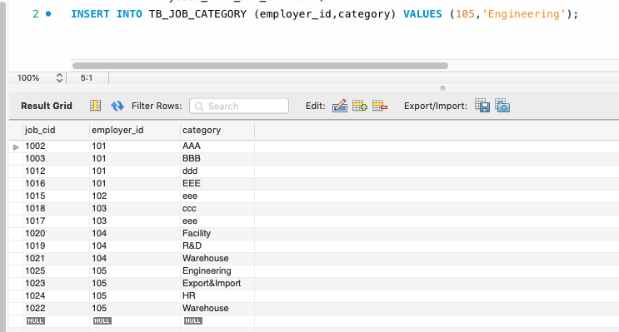

Figure 6: Output of query ii of Create

Delete:

DELETE FROM TB_JOB_CATEGORY WHERE job_cid = 1025;

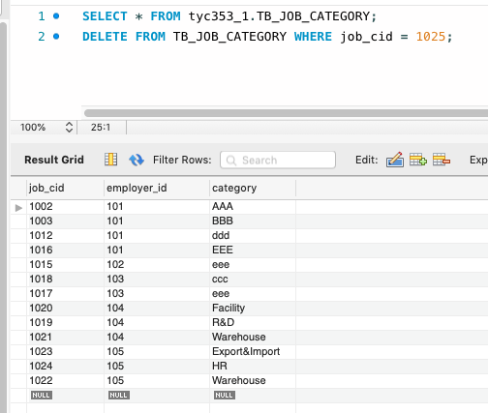

Figure 7: Output of query ii of Delete

Edit:

UPDATE TB_JOB_CATEGORY

SET category = ‘QualityControl’

WHERE job_cid = 1026;

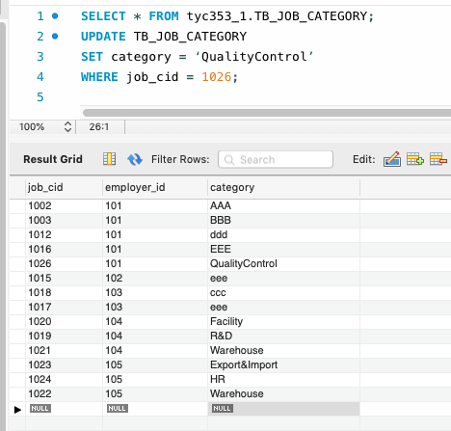

Figure 8: Output of query ii of Edit

Display

select * FROM TB_JOB_CATEGORY

WHERE job_cid = 1002;

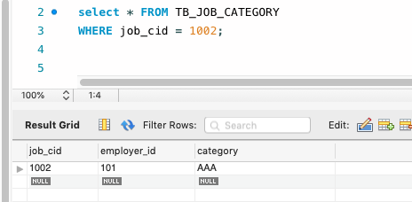

Figure 9: Output of query ii of Display

iii.Post a new job by an employer.

INSERT INTO TB_JOB VALUES (100022,'105','Tester', 1, 1022, 'Bachelor degree', 1,now());

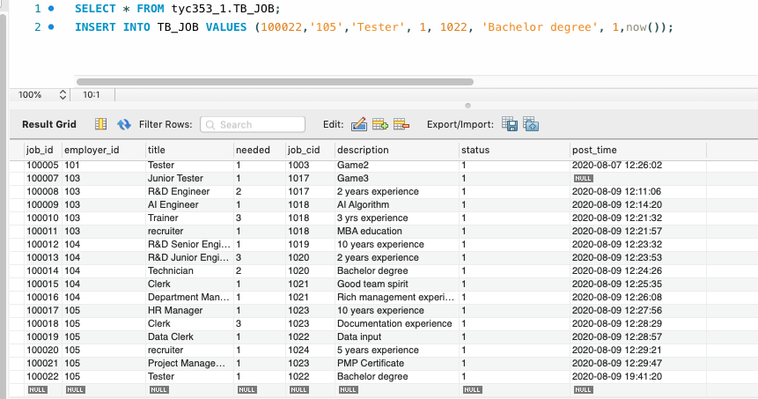

Figure 10: Output of query iii

iv.Provide a job offer for an employee by an employer.

UPDATE TB_APPLICATION

SET status_id=1

WHERE app_id = 1000007;

Remarks: status = 1 means the job is offered to employee_id = ‘100004’

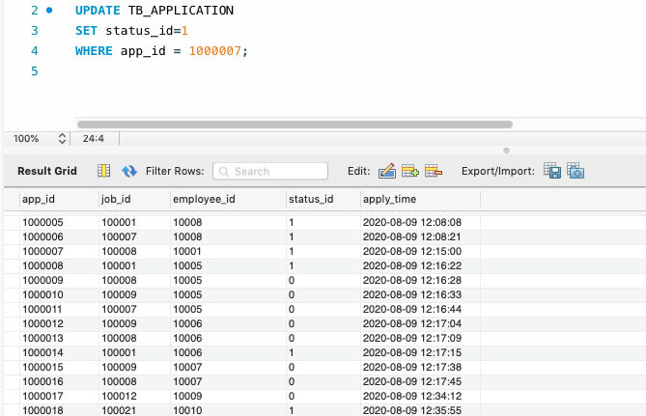

Figure 11: Output of query iv

v. Report of a posted job by an employer (Job title and description, date posted, list of employees applied to the job and status of each application).

SELECT app_id,a.job_id,title,company,apply_time,a.status_id,s.status, ee.first_name as 'applicant first name', ee.last_name as 'applicant last name'

FROM TB_APPLICATION as a, TB_JOB as j, TB_EMPLOYER as e, TB_APPLICATION_STATUS as s, TB_EMPLOYEE as ee

WHERE e.employer_id=101 AND

j.job_id = 100001 AND

a.job_id = j.job_id AND

j.employer_id = e.employer_id AND

a.status_id = s.status_id AND

a.employee_id = ee.employee_id;

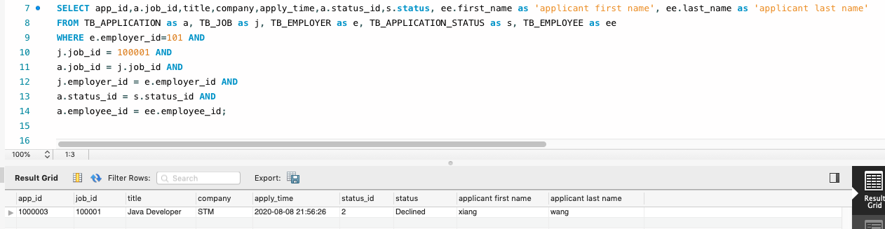

Figure 12: Output of query v

vi. Report of posted jobs by an employer during a specific period of time (Job title, date posted, short description of the job up to 50 characters, number of needed employees to the post, number of applied jobs to the post, number of accepted offers).

SELECT j.title, j.post_time, j.description, j.needed, COUNT(a.employee_id), COUNT(s.status = 'Accepted'OR NULL)

FROM TB_JOB AS j, TB_APPLICATION AS a, TB_APPLICATION_STATUS as s

where j.job_id=a.job_id and

a.status_id = s.status_id and

# s.status_id = 1 and

j.employer_id = 101 and

j.post_time > '2020-08-01' and

j.post_time < '2020-09-01'

GROUP BY j.job_id;

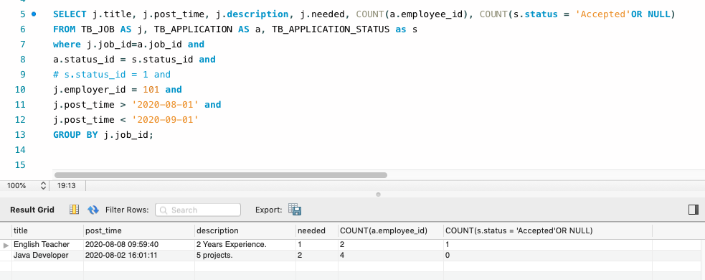

Figure 13: Output of query vi

vii. Create/Delete/Edit/Display an Employee.

Create:

INSERT INTO TB_EMPLOYEE VALUES ('10012', 'fayer', '1', 'fayer', 'farmer', 'ffarmer@yahoo.com', '0', '0', '2600', 'resumefayer', NULL, '1', NULL);

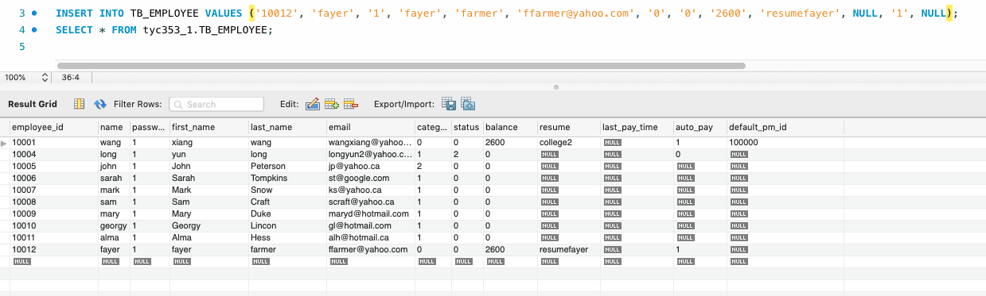

Figure 14: Output of query vii of Create

Delete:

DELETE FROM TB_EMPLOYEE WHERE employee_id=10012;

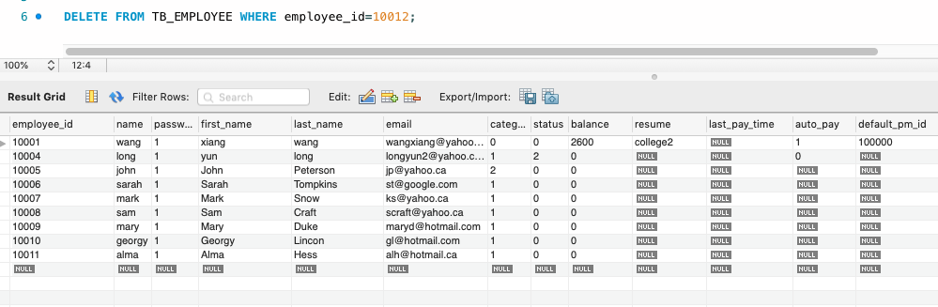

Figure 15: Output of query vii of Delete

Edit:

UPDATE TB_EMPLOYEE

SET auto_pay = 1, category =2

WHERE employee_id = 10010;

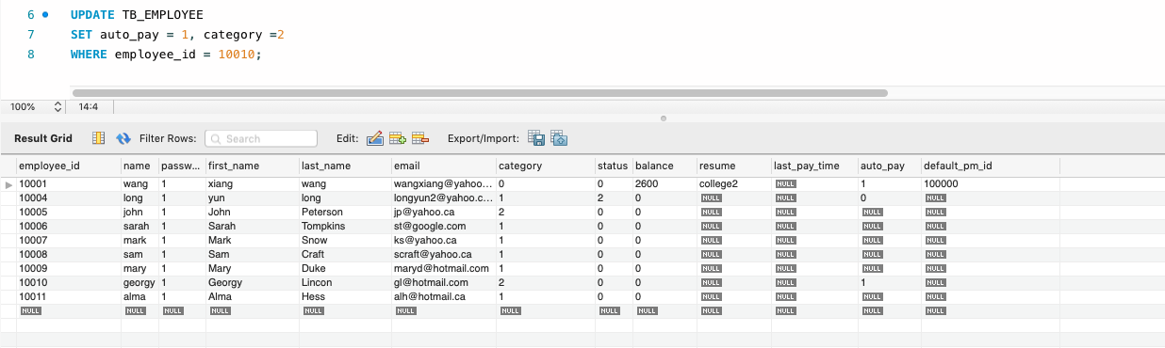

Figure 16: Output of query vii of Edit

Display:

select * FROM TB_EMPLOYEE

WHERE employee_id = 10011;

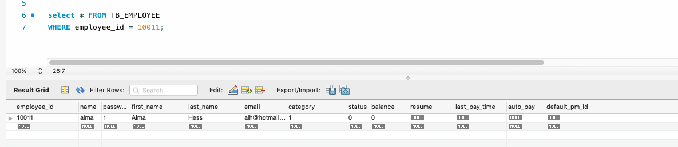

Figure 17: Output of query vii of Display

viii. Search for a job by an employee.

select *

FROM TB_JOB AS J

where J.title ='R&D Engineer';

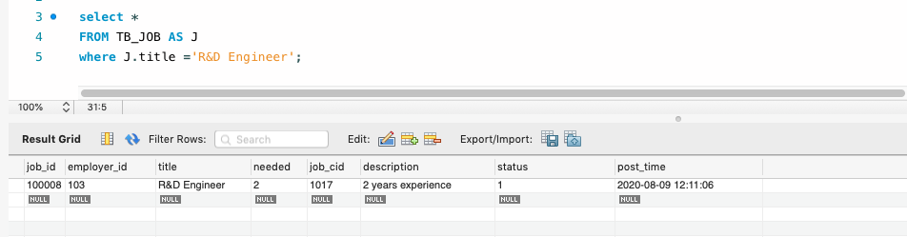

Figure 18: Output of query viii

ix. Apply for a job by an employee.

INSERT INTO TB_APPLICATION (job_id,employee_id,status_id,apply_time) VALUES (100007,10011,0,now());

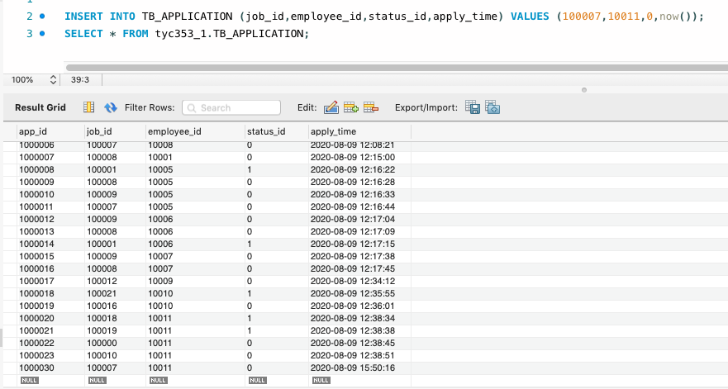

Figure 19: Output of query ix

x. Accept/Deny a job offer by an employee.

Accept:

UPDATE TB_APPLICATION

SET status_id = 3

WHERE employee_id = 10011 and

job_id = 100019;

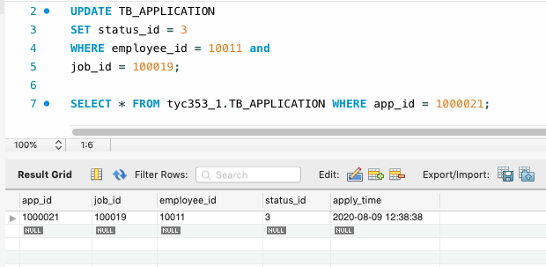

Figure 20: Output of query x of Accept

Deny:

UPDATE TB_APPLICATION

SET status_id = 2

WHERE employee_id = 10011 and

job_id = 100019;

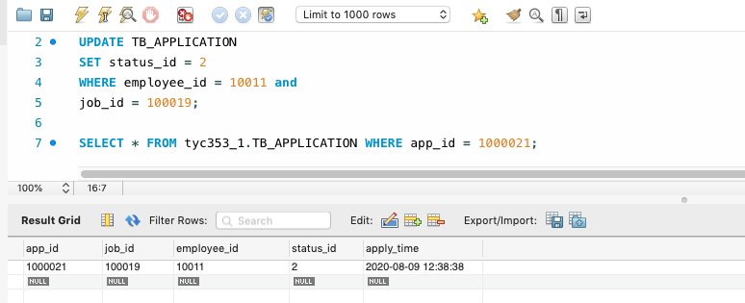

Figure 21: Output of query x of Deny

xi. Withdraw from an applied job by an employee.

DELETE FROM TB_APPLICATION

WHERE employee_id=1006 and

app_id=1000013;

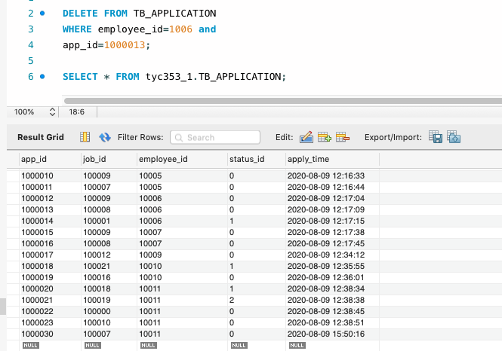

Figure 22: Output of query xi

xii. Delete a profile by an employee.

UPDATE TB_EMPLOYEE

SET resume = NULL

WHERE employee_id = 10004;

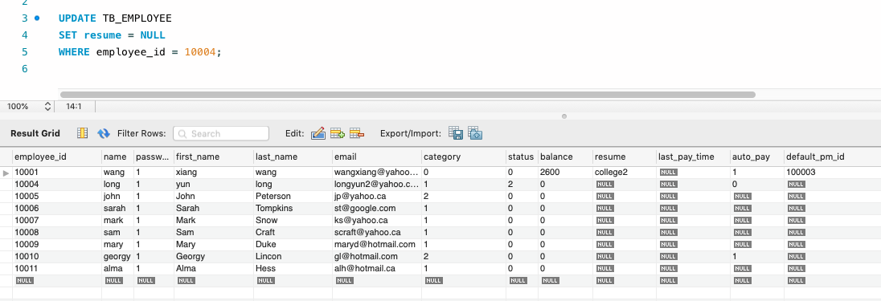

Figure 23: Output of query xii

xiii. Report of applied jobs by an employee during a specific period of time (Job title, date applied, short description of the job up to 50 characters, status of the application).

SELECT j.title, a.apply_time, j.description, s.status

FROM TB_JOB AS j, TB_APPLICATION AS a, TB_APPLICATION_STATUS as s

where j.job_id=a.job_id and

a.status_id = s.status_id and

a.employee_id = 10001;

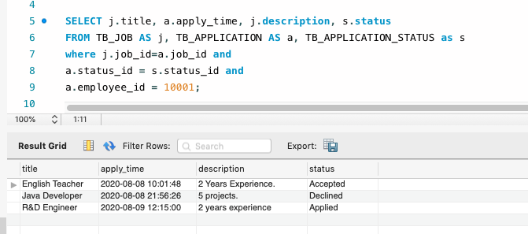

Figure 24: Output of query xiii

xiv. Add/Delete/Edit a method of payment by a user.

Add:

INSERT INTO TB_PAYMENT_EMPLOYER VALUES (1002,101, 1, 'Bob Smith', 100-323-333);

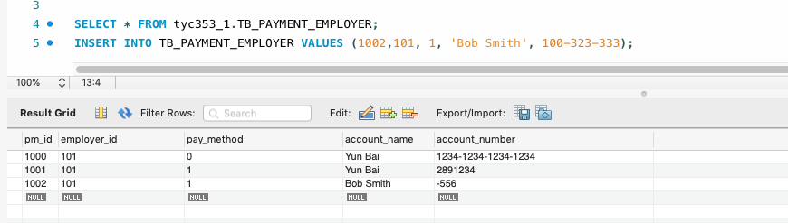

Figure 25: Output of query xiv of Add

Delete:

DELETE FROM TB_PAYMENT_EMPLOYEE WHERE pm_id=1002;

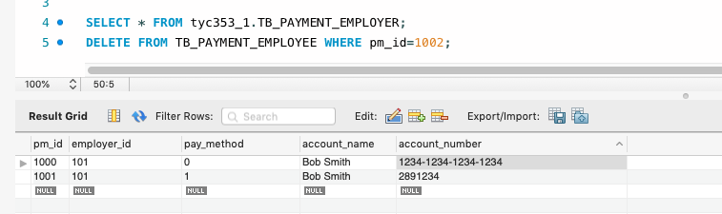

Figure 26: Output of query xiv of Delete

Edit:

UPDATE TB_PAYMENT_EMPLOYEE

SET pay_method = 0

WHERE pm_id = 1001;

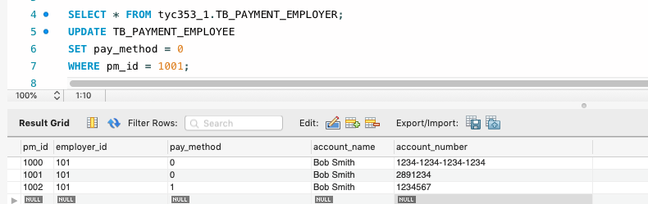

Figure 27: Output of query xiv of Edit

xv. Add/Delete/Edit an automatic payment by a user.

Create:

UPDATE TB_EMPLOYER

SET auto_pay = 0

WHERE employer_id = 104;

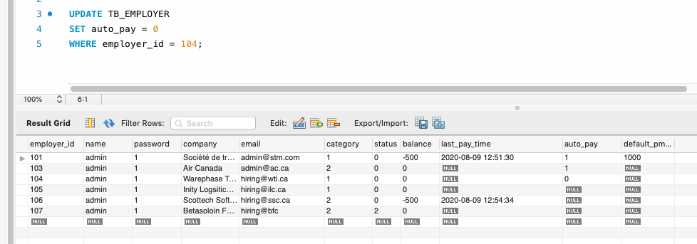

Figure 28: Output of query xv of Create

Delete:

UPDATE TB_EMPLOYER

SET auto_pay = null

WHERE employer_id = 104;

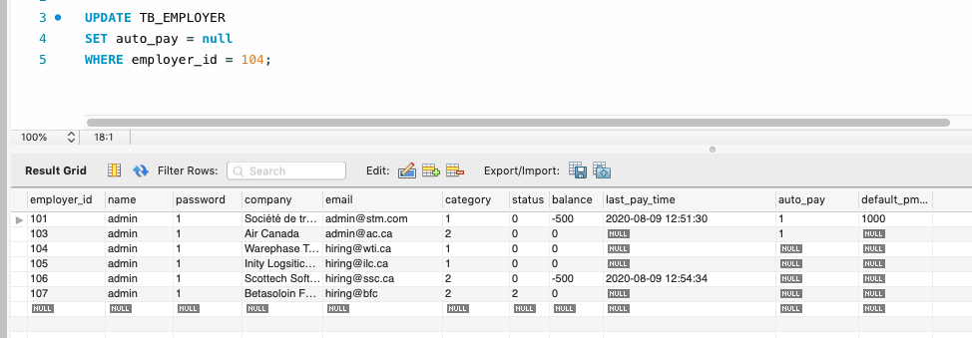

Figure 29: Output of query xv of Delete

Edit:

UPDATE TB_EMPLOYER

SET auto_pay = 0

WHERE employer_id = 104;

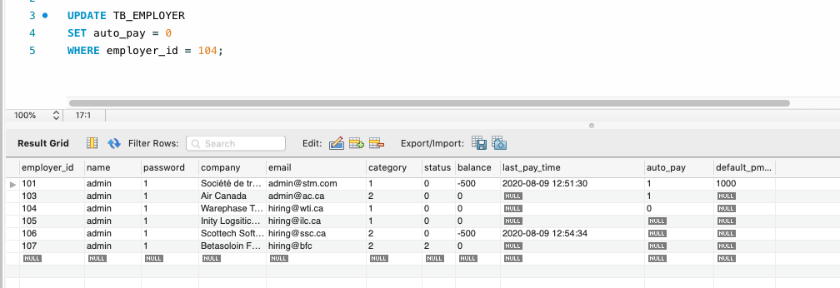

Figure 30: Output of query xv of Edit

xvi. Make a manual payment by a user.

UPDATE TB_EMPLOYEE

SET balance = balance - 200

WHERE employee_id = 10001;

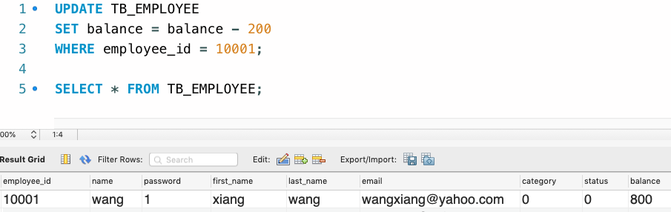

Figure 31: Output of query xvi

# All Relations Declaration

CREATE TABLE TB_ADMIN_ACCOUNT (

name varchar(45) NOT NULL,

password varchar(45) NOT NULL,

email varchar(45) NOT NULL,

PRIMARY KEY (name)

) ;

CREATE TABLE TB_ADMIN_LOG (

log_id int NOT NULL AUTO_INCREMENT,

log_time datetime DEFAULT NULL,

activity varchar(300) DEFAULT NULL,

PRIMARY KEY (log_id)

);

CREATE TABLE TB_APPLICATION_STATUS (

status_id int NOT NULL,

status varchar(45) NOT NULL,

PRIMARY KEY (status_id),

UNIQUE KEY status_UNIQUE (status)

);

CREATE TABLE TB_EMPLOYEE_CATEGORY (

category_id int NOT NULL,

category varchar(45) NOT NULL,

month_fee int NOT NULL,

limit int NOT NULL,

PRIMARY KEY (category_id),

UNIQUE KEY category_UNIQUE (category)

);

CREATE TABLE TB_EMPLOYER_CATEGORY (

category_id int NOT NULL,

category varchar(45) NOT NULL,

month_fee int NOT NULL,

limit int NOT NULL,

PRIMARY KEY (category_id),

UNIQUE KEY category_UNIQUE (category)

);

CREATE TABLE TB_AUTO_PAY (

auto_pay int NOT NULL,

value varchar(45) NOT NULL,

PRIMARY KEY (auto_pay),

UNIQUE KEY value_UNIQUE (value)

);

CREATE TABLE TB_PAYMENT_METHOD (

method_id int NOT NULL,

method_name varchar(45) NOT NULL,

PRIMARY KEY (method_id),

UNIQUE KEY method_name_UNIQUE (method_name)

);

CREATE TABLE TB_EMPLOYEE (

employee_id int NOT NULL AUTO_INCREMENT,

name varchar(45) COLLATE utf8_unicode_ci NOT NULL,

password varchar(45) COLLATE utf8_unicode_ci NOT NULL,

first_name varchar(45) COLLATE utf8_unicode_ci DEFAULT NULL,

last_name varchar(45) COLLATE utf8_unicode_ci DEFAULT NULL,

email varchar(45) COLLATE utf8_unicode_ci NOT NULL,

category int DEFAULT NULL,

status int DEFAULT NULL,

balance int( DEFAULT NULL,

resume varchar(1000) COLLATE utf8_unicode_ci DEFAULT NULL,

last_pay_time datetime DEFAULT NULL,

auto_pay int DEFAULT NULL,

default_pm_id int DEFAULT NULL,

PRIMARY KEY (employee_id),

UNIQUE KEY name_UNIQUE (name),

KEY employee_category_idx (category),

KEY employee_auto_pay_idx (auto_pay),

CONSTRAINT employee_auto_pay FOREIGN KEY (auto_pay) REFERENCES TB_AUTO_PAY (auto_pay) ON DELETE RESTRICT,

CONSTRAINT employee_category FOREIGN KEY (category) REFERENCES TB_EMPLOYEE_CATEGORY (category_id)

) AUTO_INCREMENT=10000;

CREATE TABLE TB_EMPLOYER (

employer_id int NOT NULL AUTO_INCREMENT,

name varchar(45) COLLATE utf8_unicode_ci NOT NULL,

password varchar(45) COLLATE utf8_unicode_ci DEFAULT NULL,

company varchar(45) COLLATE utf8_unicode_ci DEFAULT NULL,

email varchar(45) COLLATE utf8_unicode_ci DEFAULT NULL,

category int DEFAULT NULL,

status int DEFAULT NULL,

balance int DEFAULT NULL,

last_pay_time datetime DEFAULT NULL,

auto_pay int DEFAULT NULL,

default_pm_id int DEFAULT NULL,

PRIMARY KEY (employer_id),

KEY employer_catagory_idx (category),

KEY employer_auto_pay_idx (auto_pay),

CONSTRAINT employer_auto_pay FOREIGN KEY (auto_pay) REFERENCES TB_AUTO_PAY (auto_pay),

CONSTRAINT employer_catagory FOREIGN KEY (category) REFERENCES TB_EMPLOYER_CATEGORY (category_id)

) AUTO_INCREMENT=100;

CREATE TABLE TB_JOB_CATEGORY (

job_cid int NOT NULL AUTO_INCREMENT,

employer_id int NOT NULL,

category varchar(45) NOT NULL,

PRIMARY KEY (job_cid),

KEY job_category (employer_id,category)

);

CREATE TABLE TB_JOB (

job_id int NOT NULL AUTO_INCREMENT,

employer_id int NOT NULL,

title varchar(45) NOT NULL,

needed int NOT NULL,

job_cid int NOT NULL,

description varchar(50) DEFAULT NULL,

status int DEFAULT NULL,

post_time datetime DEFAULT NULL,

PRIMARY KEY (job_id),

KEY job_cid_idx (job_cid),

KEY employer_id_idx (employer_id),

CONSTRAINT job_cid FOREIGN KEY (job_cid) REFERENCES TB_JOB_CATEGORY (job_cid) ON DELETE RESTRICT,

CONSTRAINT job_employer FOREIGN KEY (employer_id) REFERENCES TB_EMPLOYER (employer_id) ON DELETE RESTRICT

) AUTO_INCREMENT=100000;

CREATE TABLE TB_PAYMENT_EMPLOYEE (

pm_id int NOT NULL AUTO_INCREMENT,

employee_id int NOT NULL,

pay_method int DEFAULT NULL,

account_name varchar(45) DEFAULT NULL,

account_number varchar(45) DEFAULT NULL,

PRIMARY KEY (pm_id),

KEY pm_employee_idx (employee_id),

CONSTRAINT pm_employee FOREIGN KEY (employee_id) REFERENCES TB_EMPLOYEE (employee_id) ON DELETE CASCADE

) AUTO_INCREMENT=100000;

CREATE TABLE TB_PAYMENT_EMPLOYER (

pm_id int NOT NULL AUTO_INCREMENT,

employer_id int NOT NULL,

pay_method int DEFAULT NULL,

account_name varchar(45) DEFAULT NULL,

account_number varchar(45) DEFAULT NULL,

PRIMARY KEY (pm_id),

KEY pm_employer_idx (employer_id),

CONSTRAINT pm_employer FOREIGN KEY (employer_id) REFERENCES TB_EMPLOYER (employer_id)

) AUTO_INCREMENT=1000;

CREATE TABLE TB_RECRUITER (

recruiter_id int NOT NULL AUTO_INCREMENT,

employer_id int NOT NULL,

name varchar(45) NOT NULL,

password varchar(45) DEFAULT NULL,

first_name varchar(45) DEFAULT NULL,

last_name varchar(45) DEFAULT NULL,

email varchar(45) DEFAULT NULL,

PRIMARY KEY (recruiter_id),

KEY recruiter_employer_idx (employer_id),

CONSTRAINT recruiter_employer FOREIGN KEY (employer_id) REFERENCES TB_EMPLOYER (employer_id) ON DELETE RESTRICT

) AUTO_INCREMENT=1000;

CREATE TABLE TB_APPLICATION (

app_id int NOT NULL AUTO_INCREMENT,

job_id int NOT NULL,

employee_id int NOT NULL,

status_id int DEFAULT NULL,

apply_time datetime DEFAULT NULL,

PRIMARY KEY (app_id),

KEY app_job_idx (job_id),

KEY app_employee_idx (employee_id),

KEY app_status_idx (status_id),

CONSTRAINT app_employee FOREIGN KEY (employee_id) REFERENCES TB_EMPLOYEE (employee_id) ON DELETE CASCADE,

CONSTRAINT app_job FOREIGN KEY (job_id) REFERENCES TB_JOB (job_id) ON DELETE RESTRICT,

CONSTRAINT app_status FOREIGN KEY (status_id) REFERENCES TB_APPLICATION_STATUS (status_id) ON DELETE RESTRICT

) AUTO_INCREMENT=1000000;

ALTER TABLE TB_EMPLOYEE

ADD INDEX employee_pm_id_idx (default_pm_id ASC) VISIBLE;

ALTER TABLE TB_EMPLOYEE

ADD CONSTRAINT employee_pm_id

FOREIGN KEY (default_pm_id)

REFERENCES TB_PAYMENT_EMPLOYEE (pm_id)

ON DELETE SET NULL

ON UPDATE NO ACTION;

ALTER TABLE TB_EMPLOYER

ADD INDEX employer_pm_id_idx (default_pm_id ASC) VISIBLE;

ALTER TABLE TB_EMPLOYER

ADD CONSTRAINT employer_pm_id

FOREIGN KEY (default_pm_id)

REFERENCES TB_PAYMENT_EMPLOYER (pm_id)

ON DELETE SET NULL

ON UPDATE NO ACTION;